Peculiarities of Norway compared with Sweden. An approach to understanding why active state measures have dominated regional policies for North-Norway by governments of all colours. A historical review.

Geir Conrad Tufte
Associate Professor
Østfold University College, Faculty of Computer Sciences, Engineering and Economics, Department of Economics, Innovation and Society, Halden, Norway
geir.c.tufte@hiof.no
https://orcid.org/0000-0002-3205-6098
Tel. +47 41421753

Manuscript to be presented at the NORDOM conference 26-27 August 2022, Halden, Norway. Do not cite without consent from the author.

Abstract
This article reviews regional policies in Norway after 1945. Its focus is on North-Norway compared with the northern part of Sweden. The primary data is mainly Norwegian government documents. Secondary sources are register statistics. The article aims to identify the influential factors behind regional policies. It suggests that ideas connected to the active state model in combination with peculiarities of Norway have been at the front position. While typical Keynesian ideas inhibited in the active state model have been left behind in favour of more market-oriented ideas during the last decades in public policies in Norway, governments of all colours have adhered to the active state model in regional policies in North-Norway. During the first decades after 1945 when social democratic governments ruled, bourgeois political parties objected to the active state. Eventually, bourgeois governments implemented regional policies similar to the previous social democratic ones. The article demonstrates that governments in the neighbouring state Sweden have been less active in their regional policies, despite social democratic ideas have been hegemonic in both countries. The article suggests that the peculiarities of Norway, which include geographical factors, offer an understanding of why bourgeois governments in Norway eventually adhered to regional policies linked to the active state. This understanding runs contrary to the conventional wisdom of bourgeois governments as less-state-more-market oriented than labour-based governments. Additionally, influence from the bureaucracy and bureaucrats have also been factors of influence. The influence of the peculiarities of Norway on governments’ policies, however, exceeds the influence of both the governments’ ideological foundations, Keynes’ theory’ and bureaucrats’.
Keywords: Peculiarities of Norway versus Sweden; geography; active state; regional policies; social democratic- and bourgeois governments

Introduction
The purpose of this article is to investigate ideas and aims in regional policies after 1945, especially in the region that constitutes North-Norway. This region is commonly looked upon as a periphery in the centre-periphery political cleavage. The Centre means the part of the country with a high concentration of inhabitants, economic activities dominated by the third and fourth sector, and concentration of political power. The periphery means parts of the country where inhabitants are scattered in small settlements and primary economic activities dominate. As part of the Centre-periphery cleavage, regional policies have played a major role in Norwegian development in a way, which is exceptional from a European perspective (Baldersheim, 2006: 764, 766; Heidar, 2013: 50). The Centre-periphery political cleavage is treated as part of what is called the peculiarities of Norway in this article.
Social democratic ideas have ruled across the political spectrum during the first decades after 1945 in Norway, while in the decades later neo-liberal reforms advocating slimmer states have transformed this rule (Østerud, 2005; Sejersted, 2005). This article suggests that neoliberal reforms have not wiped out social democratic characteristics in regional policies in North-Norway.

In Sweden, which serves as a comparative case in this article, the Centre-periphery political cleavage has by far been unfolded to the same degree (Lindström, 1979: 66; Heidar, 2013).
Jacob Molinder et al in an earlier article in this journal, has claimed that regional policies in Sweden only for a short period of time after World War 2 aimed at moving labour from north (the periphery) to south (the Centre) in Sweden (Molinder, 2017: 273). They claimed that this view is contrary to the view that has dominated the academic discussion on labour market policies in Sweden. They pointed out that in the early 1970s there was a decisive shift directed towards a policy stimulating employment in the north of Sweden I shall have no objections to Molinder et al’s claim. However, I shall demonstrate that regional policies in total up till today have been more influenced by active state measures in Norway than in Sweden up till today.
I shall show that the main reason for this difference between Norway and Sweden lies in the exceptional role of the Centre-periphery political cleavage, which includes geographical aspects; in sum labelled the peculiarites of Norway.

Theory and methods

When dealing with factors influencing public policies, social science studies in general, have pointed to various societal and individual factors of influence depending of context and purpose of the study. Examples of societal factors might be new technology and innovations, market conditions, class conflict, inequality, organized interests, theories and ideas, the role of governments, etc. Examples of individual factors might be “great” personalities or strategists (Slagstad, 1998; Slagstad, 2011), educational background of decision-makers, personal motivations, formal position in the bureaucracy (Egeberg, 2021), etc.. I add geography as a factor of its own in the context of this study. Thereby the article connects to the role of territory, which has been evident for some time not least in this journal, National Identities (see for example …). Regarding Norway, regional policies have been studied by political scientists and other social scientists for decades. But to the best of my knowledge, geography has rarely lied at the heart of political science research in comparative studies of Norwegian and Swedish regional policies, or as a factor influencing regional policies as part of Norway’s foreign policy in North-Norway. So, I have chosen geography, as well as theories/ideas, and educational background of bureaucrats as key factors of influence in regional policies for North-Norway and Sweden.
Regarding geography, Norwegian regions consist of the heavy populated South-East region where the capital Oslo is situated, commonly called “the centre” in the centre-periphery political cleavage, and the peripheral regions South-West Norway and North-Norway .
The article includes a section about the neighboring country Sweden. According to the Norwegian historian Francis Sejersted, the social democrats in Norway and Sweden exerted a “hegemonic position” until the 1970s (Sejersted, 2005: 15). This position implied that “the competence and the role of the state was widened” (333). Social democratic governments since 1945 have dominated in both countries (Sweden even earlier). Governments in Sweden have implemented a contrasting version of the Nordic social democratic governance than that of Norwegian governments.
The article uses the expression “the peculiarities of Norway” as a sticky label for certain characteristic features of Norwegian geographical regions. These peculiarities refer to the strength of the peripheral regions of the country and the egalitarian ideas among the inhabitants (Østerud, 2005). The article includes social democratic ideas as a part of these peculiarities. Some scholars have described Norway as “a nation of the triumphant periphery” (Baldersheim, 2006, p. 771). The triumphant periphery refers to the power of the periphery that has been based upon socio-economic and political features like industrialization built on energy provided by waterfalls and coastal economy (Baldersheim, 2006, p. 771). I am adding offshore oil- and gas resources as part of the coastal economy. Østerud has claimed that the peculiarities have been increasingly outdated (Østerud, 2005). This article argues that geography ought to be treated as a peculiarity of its own in the context of North-Norway, because geographical factors exert a significant influence on regional policies for that part of the country. These factors, besides the old peculiarities connected to waterfalls and fisheries, consist of two parts: one regards the boarder to Russia, and the other regards the global warming, which in the near future might open the North-East sailing route for merchant shipping around North-Norway.
Regarding theories and ideas, the article argues that the social democratic ideas, which were mentioned above, have ruled in Norway since 1945 and continues to do so as regards regional policies for North-Norway (Østerud, 2005). Social democratic ideas imply that governments take an active state position. Even though the concept active state is a vague concept, it seems to be a generally accepted interpretation that an active state is one where the government intervenes in the economy and supplies welfare benefits (Hoffman, 2009, p. 89; Lie, 2012, p. 99). Policies of the active state links closely to the ideas developed by the English economist John Meynard Keynes in the 1930s (Keynes, 2008). His analysis provided a theoretical rationale for the active state, and thus of a government’s role in the management of the economy (Hooglund, 2001, p. 467). The minimal state is a contrasting model where the state is a monopoly provider of security services only (Hoffman, 2009, p. 89). The active state and the minimal state are two models where the pure model lies in each end of a continuum. In Norway, bourgeois parties with the Conservative party in the forefront have tended to be skeptical with regard to state intervention in the economy in general (Baldersheim, 2006, p. 774). Higher transfer of money to the northern area than to the rest of the country (Ørbeck, 2007, p. 22), and a generous tax regime to enterprises, firms and inhabitants there, are the main characteristics of the active state in regional policies in North-Norway. The article applies the label active state to characterize regional policies in North-Norway after 1945.
Another idea is from the German sociologist Max Weber (1864 - 1920), who argued that “(t)he power position of a fully developed bureaucracy is always great, under normal conditions overtowering” (Weber, 1978, p. 991). Many social scientists today have argued in line with Weber; bureaucrats in public administration are not neutral instruments in the hands of shifting governments, but an important agent in its own right (Olsen, 2018).

Weber’s theory has had strong support in studies of Norwegian bureaucrats. The historian Rune Slagstad claimed that politicizing bureaucrats have been a feature of the Norwegian political system since 1814 (Slagstad, 2011, p. 300). Various Norwegian academics have argued that influence from bureaucrats who belonged to the Keynesian school of economy may account for the active state policies of governments of all colours. One reputable example is the influence from an economist, who hold positions in the labour governments during the first two decades after 1945 as minister of trade, minister of finance, and as head of Bank of Norway, and various positions in development of regional policies. Regional policies were something of a child of his heart (Baldersheim, 2021). Typically, the label “Iron Triangle” has often been used to characterize the strong connections between high ranking government bureaucrats, a committee in the parliament (i.e. Storting) and organised interests (Østerud, 2014: 74). Østerud concluded that the label Iron Triangle generally gives too bastant associations, but that the bureaucracy never the less has independent influence on public policies (74, 75).
The article focuses mainly on regional policies that benefit North-Norway, i.e. the three counties Nordland, Troms, and Finnmark. Most of this region is situated north of the Polar circle and has an Arctic type of climate in winter in the inner areas and milder climate in the coastal areas. Finnmark county shares a boarder with Russia.
The analysis consists of two comparisons: one compares ideas and aims of regional policies in Norway under social democratic and bourgeois governments (on two occasions I use the party program from the time before the Norwegian Conservative party came in government positions); the other comparison deals with Norway and Sweden.
The first comparison looks for ideas in regional policies by social democratic and bourgeois governments after 1945, while the second looks for similarities and differences between Norway and Sweden. The argument for comparing Norway and Sweden is that social democratic ideas have been hegemonic in both countries’ governments during the period (Sejersted, 2005).
The article’s main purpose is to describe and compare ideas and aims of regional policies in Norway, not of results. One can assume that ideas and aims influence results, but often there is a discrepancy between them. An essential discrepancy in Norway is between the aim of getting similar living conditions all over the country, but results show that peripheral areas dominated by fisheries and agriculture have been deprived wholly or partially of, schools, post offices and other establishments. Hence, people have moved to areas that are more central. Behind this deprivation, strong forces are at work towards a continuing moving of people to central areas of the country (Bull, 2020). This article compares ideas and aims of different governments’ regional policies in Norway, and discusses reasons to why these have influenced regional policies up till today. So, the discrepancy between aims and results in Norway lies outside the main purpose of the article.
Regarding the comparison Norway to Sweden, the article focuses even on results. The reason is that this comparison seeks to uncover whether similar hegemonic ideas, i.e. the social democratic ideas, might have given similar results. If different results can be uncovered one might suggest that other factors than the hegemonic ideas have been at work.
The data consists of government documents, political party programs, a biography from a prime minister, a history book from a renowned historian, and a study by an American scholar about regional policies in Norway. These are the primary sources of data. I regard these documents as genuine evidence, of unquestionable origin, of high credibility, and representative of regional policies in the period. In the selection of documents, I have relied on my professional judgement, which is based on a mixture of analytical reasoning, academic studies, and professional intuition. I am not aware of public documents that renders a significantly different picture from the documents that I have put forward here, but it is necessary to mention that many public documents describe elements in regional policies that are not visible in this article.
I have done online searches in the documents for various words connected to regional policies in order to identify the content of these policies. Some material exists in print only. These are the biography from the prime minister, the history book, and the study by the American scholar. I have identified the content for these documents by reading the printed text.
The data about results of regional policies are register statistics, which are secondary sources in the study.
The table below displays the sources of the study.
Table 1. Documents selected and data analyzed
Documents | Data analyzed
Archives of political parties 1945(NSD) | The political parties’ communal program 1945 about the purpose of economic life
Government message to the Storting 1947 (St. meld. 10 1947) | Policies about reconstruction of North Norway after the Second World War
Prime minister’s memoirs 1945-55 (Gerhardsen, 1971) | Comment on unemployment in North-Norway during reconstruction years
The Conservative party (NSD) | The election program 1965 about regional policies
The ascent of regional policy in Norway, 1945-1980 (Soderlind, 1999a) | Facts and ideas about regional policies in Norway 1945-1980
The Conservative party (NSD) | The election program 1988 about regional policy
Helhetlig regionalpolitikk [Integrated regional policies] | Labour government’s regional policies 1992-93
Ministry of Local Government and Modernisation: A brief history of rural and regional policy in Norway (modernisation, 2015) | Facts and ideas about regional policies 1961-2015
Statistics Sweden (SCB.se) | Patterns of townships and villages in Sweden 1960-2010
Take all of Norway into use (Government, 2013a) | Facts and ideas about regional policies of the labour government 2012
The social democracy’s century: Norway and Sweden in the 20th century] (Sejersted, 2005) | Idea about regional policies in Norway and Sweden
European perspectives about regional development in Norway (ESPON, 2020) | Proportion of employees in public sector in North Norway and North Sweden
ESPON (European Observation Network for Territorial Development and Cohesion) (ESPON, 2019) | Territorial patterns and relations in Norway and Sweden 2016
Thriving local communities for the future (Government, 2019) | The bourgeois government’s regional policies

References introduced in the Discussion section below are not mentioned in the table above because they are neither primary data nor secondary sources in this context.
All quotes from public documents are translated from Norwegian to English by the author if not otherwise is noted.

The active state in regional policies in Norway – social democratic and bourgeois policies compared

The reconstruction after World War 2 marks the start of the social democratic era in Norway (Sejersted, 2005). The labour government adopted more ambitious goals for its economic policies than those of most other Western governments (Bjerkholt, 2014: 301).
The main goal of the reconstruction was to stimulate worthy and comparable living standard all over Norway as soon as possible. An active state was an inevitable implication of this aim. It was a much agreed upon aim that included the bourgeois parties. First and foremost because the need of reconstruction of the areas in the northern part of the country, which were severely devastated during VW2. One of the central parliamentarians in the Conservative party at that time and later prime minister for a short time, John Lyng, wrote in his memoirs about his party’s support: “Words and concepts like social coordinated regulation by the government – in contrast to private initiative, innovation and free enterprise – were in frequent use by all sides (…). But this support was defined by the situation at that time and did not last long” (Lyng, 1972: 225, 226).
In 1950 the labour government launched an economic program for North-Norway which retained much of the regional favouritism from the previous five years (Soderlind, 1999: 10). The program challenged the traditional bourgeois ideas of the proper role of the state in economic affairs. It was heavy influenced by key persons in the labour government and the surrounding party elite of economists, who were keen advocates of the theories of John Maynard Keynes (Sejersted, 2005: 329). His ideas favoured a state planned economy before the market (Sejersted, 2005: 174, 321).
It is generally believed that the ideas behind the regional policies in Norway have been hegemonic until the beginning of the 1990s (Knudsen, 2017; Teigen, 2012; Sejersted, 2005). This article suggests, as already mentioned, that these ideas have been hegemonic even longer with regard to North-Norway.
The Norwegian version of Keynes’ theory was a strong corporate state, i.e. big organizations in economic life assembled under the leadership of the government in cooperative decision-making bodies. Both national growth and regional redistribution of resources were emphasized ((paraphrased from Jakobsen (2014: 82)). The label “planned economy” (Norwegian: planøkonomi) came to be the label that symbolized the key instrument in the governments’ economic policies.
A joint program edited by leading figures in the labour party and the bourgeois parties in 1945 came to exert heavy influence on all policy fields during the first decade after 1945. This program, titled the Communal Program (Fellesprogrammet), stated that the purpose of economic life was to create work for everybody and to increase production. A wish to use all resources in all parts of the country was a common denominator in the political parties’ programs of the time (NSD).
One of the government’s first priorities after the war was building of homes in the two most northern counties. The Nazi German occupation forces had destroyed most of them in 1944. A broader program was decided in 1951, which aimed at creating a development program for all three counties in North-Norway. This program contained special taxation rules, and other extraordinary instruments for the region (Teigen, 2013). Opposition parties argued that The North-Norway program, as it was labelled, embodied a new initiative of central authorities’ control over traditionally local affairs (Soderlind, 1999b).
The beginning of the Cold War after WW2 had shaped a vulnerable situation for North-Norway because it shared a border with the Soviet Union. According to Soderlind (1999b, p. 3) the defense aspects of the reconstruction of North Norway are generally played down. Most probably, defense rationale played an important role in the government’s reconstruction plan for Northern Norway. Norway joined the North Atlantic Treaty Organisation (Nato) as soon as it was established in 1949.
The labour government acknowledged before long that North-Norway needed more than reconstruction of the damages from the war. Therefore, in 1951, a new law opened for entrepreneurs to invest in funds to support of new industry in North-Norway and other areas characterized with lack of workplaces, and with low level of income (Lie, 2012: 91).
An alternative plan for reconstruction might have been to move labour force from north to south as a solution to meet a growing demand for work force in the south of Norway, and to reducing the increasing unemployment in the north. The government at that time opposed that alternative. The prime minister declared in his memoirs that “(T)his would not be a desirable solution” (Gerhardsen, 1971, p. 130).
The planned economy of the labour government encountered strong objection and criticism from the bourgeois political parties and from the employers’ organizations during the 1950s. The bourgeois political parties objected to the active role of the state, and liberal bourgeois intellectuals brought to the political debate ideas from the economist, Friedrich A. von Hayek, who like Keynes had developed his theory during the 1930’s. In the book The Road to Serfdom, published in 1945, Hayek warned that continuing the planned economy from the wartime would be a road to serfdom (Jakobsen, 2014: 84). For example, in the public debate around the North-Norway Development Fund in 1952 the proper role of state in economic affairs dominated. The bourgeois parties expressed fear that if the state were to interfere with economic development, short-term political considerations would guide investment rather than the country’s best international prospects (Soderlind, 1999: 10). Neither Hayek’s ideas nor fears from the opposition with similar ideas came to influence Norwegian regional policies during the reconstruction period.
Disagreements within the labour party in the early 1960’s opened for a shift to governments of bourgeois parties. It turned out that this did not change the lines from the previous labour governments’ way of using public economic mechanisms and regional development policies (Lange, 2020).
The 1965 program of the Conservative party exhibits an ambiguous attitude to the active state in regional policies. On one side, the program expressed skepticism when it declared that “(t)he government led establishment of industries as a mechanism in regional development has been very unfortunate. A lot of capital has been lost to insolvent and bankrupt enterprises”. On the other side, the program was in favour of “construction of public roads that can be open all the year, support of costal merchant marines, and support of main flight routes (…). (A) whole set of communication needs have to be met without being profitable in a narrow sense”. It mentioned military defense as one of these needs (Høyre [The Conservative party], 1965: 25, 28).
The first long lasting bourgeois government after the labour governments’ rule 1945-65 was established in 1965. A prime minister from the Center party headed a coalition government with the three other bourgeois parties in the Storting (i.e. the parliament). The Center party was formerly called the Agrarian party but had changed its name in the 1950’s. Its ideological basis was, and still is, a concern for living conditions outside the central regions.
According to Soderlind, the policies of regional growth that existed were used actively by the new bourgeois government, and “augmented with additional subsidies and controls over the location of large enterprises and institutions” (Soderlind, 1999: 22). In 1968, the bourgeois government created a special state-owned company. The Norwegian Industrial Estates Company (Selskapet for industrivekstanlegg) come to be its English name. It was empowered to construct and operate industrial sites in approved growth centers (Soderlind, 1999: 23). Growth centers was an idea that originated from The Regional Development Fund back in the early 1960s during the reign of the labour government (Soderlind, 1999: 22). These examples illustrate that the bourgeois government at that time did not make significant moves away from the active state in its regional policies, but rather developed it.
At the end of the 1970s, Norwegian economists began to recommend more market-oriented solutions and to let the government play a minor role in a broad specter of policy areas. The rationale behind these recommendations came from economic liberalists, where Joseph Schumpeter, Friedrich Hayek and Milton Friedman were the most prominent. President Ronald Reagan in USA and Prime minister Margaret Thatcher in Great Britain were the most outstanding persons in power to climb on the bandwagon of the economic liberalists (Lie, 132).
Schumpeter, Hayek and Friedman’s ideas fitted more to traditional bourgeois policies than to social democratic ones. For example, a Schumpeterian thinking went along with a neoliberal policy approach that restricted the role of state interventions to setting up regulatory frames and supporting an entrepreneurial climate (Tödtling, 2018). Norwegian governments and political parties were hesitant to apply these ideas and kept a major part of their belief in state intervention, in line with Keynesian ideas of governance, during the 1970’s. The strongest economic sectors outside cities and towns, agriculture and fisheries, benefitted quite well from this reluctance, as demonstrated by a large increase of state subsidies (Lie, 2012: 129).
To improve educational opportunities in the regions, new state-run university facilities were built in North- and Mid-Norway in the 1960s; in the 1970s a new type of higher education institution named distriktshøgskole (eng. Regional University College) was located outside the most central parts of the country. The name signaled its role in the labour and bourgeois governments’ regional policies.
The governments kept their belief in active state intervention as a vehicle to increased economic development throughout the country. This belief was expressed by the way the governments regulated and controlled capital- and credit markets as a continuation of their active regional policies (Lie, 2012: 99, 100).
The Norwegian oil and gas adventure began in 1969. In 1972, the labour government looked upon this as an opportunity to create a state owned oil company, Statoil, and initiated a principle of 50 percent state participation in each production licence.
The 1980s saw two bourgeois governments and one labour government. One can hardly find any significant difference between the governments’ regional policies. In 2015, the bourgeois government published a look-back document about regional policies in Norway during the foregoing 50 years. The document characterized the 1980s as follows:
“…(P)olicies changed in the 1980s. There were fewer large industrial projects, and with the liberalization of interest and credit policies, the state became less important as a source of capital. There was less faith in official planning, and new methods for governing society were introduced, including goal management and competitive tendering” (Ministry of local government and modernisation, 2015).
Most people would agree that this characterisation signalled that a change towards a reluctant attitude to the active state had taken place. It renders a picture of policies that involved less state and more market. This is not a surprise since neo-liberal ideas of economic policies had had an impact on governments of all colours in many countries in Western Europe, North America, Australia, and New Zealand at that time.
But regional policies kept its mark from the active state, as the next two quotes indicate. The first quote comes from the Conservative party’s program to the parliament election in 1988. It stated: “The overall goal of the Conservative party’s regional policy is to improve economic development, and to safeguard settlement and living conditions in all parts of the country” (The Conservative party, 1988: 38).
This quote, especially the words “all parts of the country”, signalled a reassertion of the active state in regional policies, which leading politicians all over the political continuum had written in the Communal program in 1945, as mentioned above.
Likewise, the labour government of 1990 - 96 in a message to the parliament echoed the pattern of the policies from the early reconstruction period: “The main aim for integrated regional policies is to contribute to developing sustainable regions in all parts of the country, with balanced settlement pattern, and equity in employment and welfare services” (Government, 1993: 6).
We recognize the phrase “in all parts of the country” in the two last quotes. As we shall see, this phrase continued to be a significant element in regional policies.
The bourgeois coalition government that reigned 1997-2000 (Bondevik I) declared that its “(…) central aim for the regional policies is: to maintain the main settlement pattern; (and) to develop robust regions in all parts of the country”. In a subsection of the same document the government declared that regional policies in all areas are the factors of most importance for living conditions and settlement patterns, and that the government’s policies aimed at compensating for some of the competition disadvantages of being far away from the markets (Government, 1998: Picture 15).
The same aim continued to be a significant element in government documents after 2000 and up to today, as shown by the next examples.
The bourgeois government who ruled from 2001to 2005 (Bondevik II) declared on its inaugural session its understanding of regional policies:
“Well-intentioned economic development policies are good regional policies as well. Important fishing industries, fish farming industry, agriculture, and tourist industry, contribute to wealth creation in sparsely populated areas, and good living conditions all over the country” (Government, 2001).
The labour government who ruled from 2005 to 2013 (Stoltenberg II) declared:
“its intention to keep the main elements in the settlement pattern. We will use the human and natural resources all over the country in order to make greatest possible national wealth, secure living conditions, and give everybody genuine freedom to settle wherever they want” (Government, 2013).
This declaration received broad support in the parliament. A few proposals from the Liberal party about changes of organizational sort received support only from the two small parties - the Liberal party and the Progress party - but the Storting (parliament) voted finally unanimously in favour of the message.
A noteworthy point to mention regards the change in outlook about regional policies that the far-right wing Progress Party went through during the 1990s. That party had originated as a liberal market-oriented party in the 1970s. Lower taxes and less state regulations were the party’s trademark, and its regional policies did not favour North-Norway. Parliament elections returned, not surprisingly, less votes from North-Norway than from rest of the country to the party. In the late 1990s, the Progress Party changed its attitude towards strong support of a generous welfare state for inhabitants in all parts of the country, and voters in North-Norway became more positive to the party. At the parliament election in 2017, the party had gained a higher proportion of votes in the three northern counties than it did of the total votes of the country. (See nrk.no (Corporation], 2017) and Statistics Norway (Norway], 2017) for details of parliament elections).
The present government (Solberg) is a bourgeois coalition government who has reigned since 2013. To bring this section to close, I present the basic content of its regional policies for North-Norway: Regionally differentiated social security contributions for employers, lower income tax for individuals, generous financing of studies for students who settle there after having finished their studies, and reduced electricity tariff for households. For the most northern parts (Nord-Troms and Finnmark) the government has exempted employers for paying social security contribution. The municipal revenue system, where the state redistributes income taxes from rich municipalities to poor municipalities, also plays an important role in its regional policies (Government, 2019).
Table 2 summarizes the body of evidence identified as active state indicators in labour led and bourgeois coalition government’s regional policies since 1947.
Table 2. Indicators of active state regional policiesSimilarities between labour governments and bourgeois governments in regional policies
Documents stemming from labour or bourgeois government | Quotes from public documents that indicate an active state role
Labour government document 1947 | “(to) raise the living conditions to equal level in the districts as in the towns” (St. meld. 10, 1947).
Conservative party parliamentarian and future prime minister, John Lyng, Memoirs | As regards the first eight years after 1945: “…words and concepts like social coordinated regulation by the government – in contrast to private initiative, innovation and free enterprise – were in frequent use by all sides” (Lyng, 1972: 225).
Conservative party program 1965 | ” The (Conservative) party is in favour of construction of roads that can be open all the year, support of costal merchant marines, and support of main flight routes” (party], 1965).
Conservative Government document 1967 | “…a broad set of regional policies aimed at improving living conditions in areas of the country that had lagged behind the development in the rest of the country” (Om Distriktsplanlegging [About regional planning], p. 33).
The Conservative party program 1988 | “The overall goal of the Conservative party’s regional policies is to improve economic development, and safeguard settlement and living conditions in all parts of the country” (The Conservative party, 1988: 38).
Labour government 1990 | “The main aim for comprehensive regional policies is to contribute to developing sustainable regions in all parts of the country, with balanced settlement pattern, and equity in employment, and in welfare services” (Government, 1993, p. 6).
Bourgeois government 1997 | “(The government) aims to work throughout the country. Workplaces, funds, and (political) power ought therefore to be decentralized” (Government, 1997).
Bourgeois government 2001-2005 | “Well-intentioned economic development policies are good regional policies as well. Important fishing industries, fish farming industry, agriculture, and tourist industry, contribute to wealth creation in sparsely populated areas, and good living conditions all over the country” (Government, 2001).
Labour government 2005-2012 | “(The government) will use the human and natural resources in all the country in order to make greatest possible national wealth, secure living conditions, and give everybody real freedom to settle wherever they want” (Government, 2013).
Bourgeois government 2013 | “We wish that people shall live all over the country (…). We shall improve the growth potential and create opportunities for good living conditions over the entire country” (Government, 2013b).
Bourgeois government 2017 | “(…) citizens in Norway are going to have equal living conditions wherever they live” (Government, 2017).
Bourgeois government 2017 | The government aims to make North-Norway one of the most creative and sustainable in Norway (Government, 2017: 3).
Bourgeois government 2019 | “The government wishes to have thriving local communities all over the country” (Government, 2019: 7).
Source: Own compilation from a selection of documents about regional policies.

The overall picture demonstrates that bourgeois political parties and bourgeois governments have maintained an active state role in regional policies at least since the mid 1960 until today.

Norway’s regional policies compared to Sweden’s

Right after 1945, central goal for the social democratic government in the neighboring country Sweden was to build a better future for their inhabitants. We recognise this goal as similar to the Norwegian labour government’s in the same time priod. In addition, governments in both countries were aiming at full employment. But, soon after 1945 a significant difference became visible between the social democratic governments in the two countries.
While the Norwegian government aimed at creating good living conditions for everybody all over the country, the Swedish government instigated incentives for people to move from the northern part of the country with its harsher natural conditions and weak infrastructure to the south where most of the industry was and where the need for labour force was high (Lie, 2012: 103; Sejersted et al., 2005). The economic conditions have been and still are meagre in the north of Sweden. Oil and gas resources have been absent and commercial fishery has been of considerably lower importance in the north of Sweden than in the north of Norway (Sweden - food and agriculture organization, 2004). In North-Norway, as mentioned earlier, the coastal economy based upon rich fisheries, and oil- and gas resources off-shore, has given better conditions for demographic stability (Baldersheim, 2006: 771).
As a result of the Swedish government’s incentives, a huge migration from north to south followed (Sejersted, 2005: 249). Five hundred small settlements disappeared during the years 1950 to 2010. Map 1 below illustrates this migration. Settlements disappeared even in the south, but mostly because they grew together with a neighboring town (SCB.se). The historian Sejersted paraphrased the Swedish political scientist Bo Rothstein who had stated that this migration introduced the modern state interventionism in Swedish public administration (Sejersted, 2005: 245). According to Sejersted, the way the Swedish government became a directing agent of labour force migration, turned out to be a special aspect of the Swedish social democracy (Sejersted: 246).
After the 1960s Sweden has adjusted its regional policies to some degree by moving jobs to certain northern towns (Soderlind, 2012). Yet, the reduction of townships and villages has been noteworthy, which is apparent in Map 1.

Map 1. Number of Swedish townships and villages 1960 and 2010
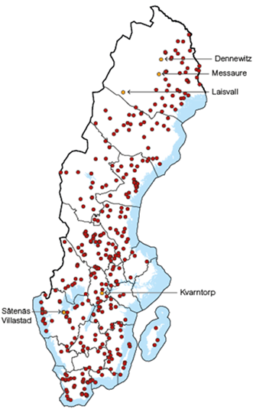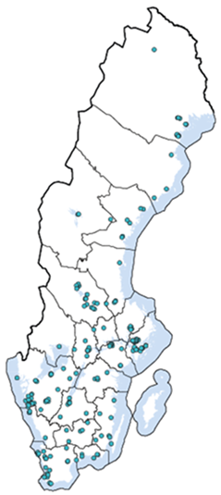
Sweden 1960 Sweden 2010
Source: (Sweden), No date)

With reference to these descriptions and statements, the migration in Sweden is a telling example of active state policies, nonetheless with different aims in comparison to what Norwegian governments have expressed regarding settlement pattern.
Another difference between the two countries in regional policies regards unemployment rates. The next map conveys that Norway has performed better than Sweden (and the other Nordic neighbouring countries Finland and Denmark) in keeping low unemployment rates over its entire area. The colours in the map regard unemployment rates in per cent in 2016. Dark green exhibits unemployment rates between 1.0 and 2.5 per cent, Green: 2.6-3.0. Light green: 4.1-5.0. Yellow: 5.1 – 7.5. Orange: 7.6-10.0. Dark Orange: 10.1-15.0.

Map 2. Unemployment rates 2016
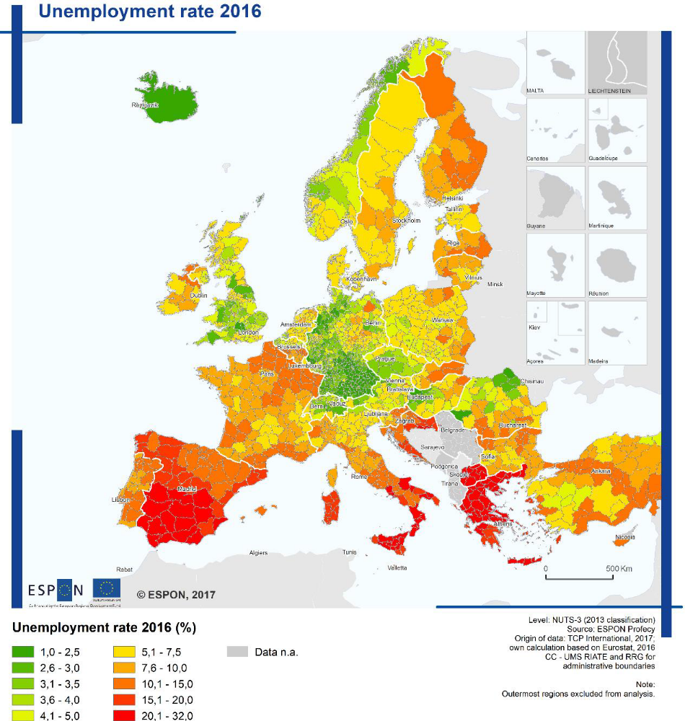
(Finland))
North Sweden
North-Norway
NNNNorrway
Swede
Swn
Source: (ESPON, 2019)
The map above demonstrates that North-Norway in 2016, even the most northern part of North-Norway, had lower unemployment rates than North Sweden.
The next map pictures purchasing power per person between the two countries and regions (and the rest of Europe). Purchasing power is an important benchmark for the economic strength of a given region. GfK Purchasing Power Europe, which appears in map 3, is a recognized benchmark in the market for calculating consumer potential and shows the regional distribution of disposable income among the population (between individual countries as well as between the various regions within a country). (Frank, 2020).
Map 3. Purchasing power Europe 2019
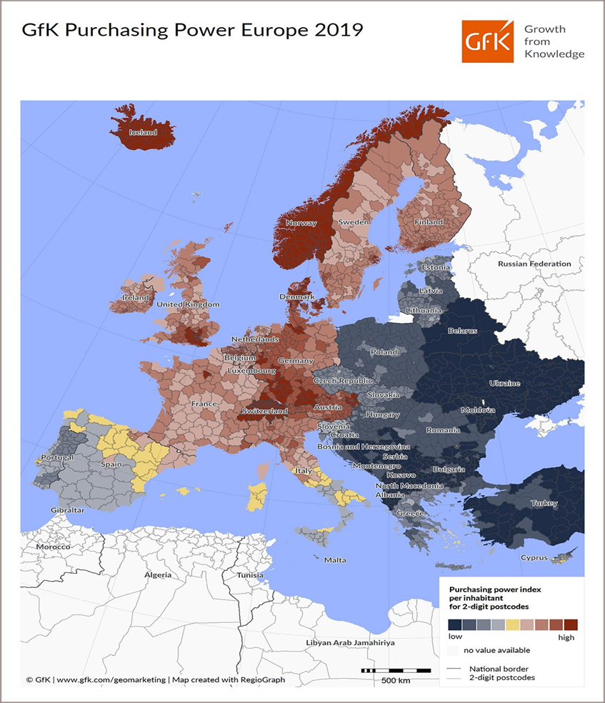
Source: (Knowledge, 2019)
Illustration: GfK

Map 3 demonstrates that the purchasing power per person in Norway was much higher than in Sweden (and the rest of Europe except Lichtenstein) in 2019. Norwegians had an average of €14,739 per person available for spending and saving in 2019.
While we are looking at map 3, we notice that Sweden in contrast to Norway has no boarder to Russia, which illustrates geography as another important difference between the two countries.
From these comparisons, we have seen that Norway and Sweden differ from each other on two aspects of regional policies: Norway has aimed at supporting living conditions in North-Norway, while Sweden has aimed at supporting industry in the middle and southern parts of the country by moving labour force from its northern parts.
The table below summarizes the factors of influence identified as main similarities and differences between Norway’s and Sweden’s regional policies.
Table 3. Factors of influence in regional policies in Norway and Sweden
Similarities and differences | Norway | Sweden
1. Active state in regional policies | Yes | Yes
2. Hegemonic ideology | Social democratic | Social democratic
3. Labour market policies | Full employment | Full employment
4. Type of active state in northern parts | Considerable presence of public administration, use of subsidies and subventions to businesses and households | Less presence of public administration, use of subsidies and subventions to businesses and households
5. Peculiarity: Centre-periphery political cleavage | Strong | Weak
6.Peculiarity: Geography | Important factors: fisheries, oil and gas, boarder to Russia, part of the North-East sailing route | Absence of geographical factors similar to North-Norway
Source: Own compilation
In total 3 similarities and 3 differences among the 6 factors in the table.

Discussion

The discussion contains two parts. First, we discuss why both bourgeois governments and social democratic governments continued the role of the active state in North-Norway; second, we discuss why Norway and Sweden differ regarding regional policies in their northern areas.

I started this paper pointing to theories about bureaucrats: Norwegian bureaucrats who worship Keynesian ideas, which include social democratic ideas, have influenced the governments to perform in the role of active state in regional policies; and from Max Weber’s theory of bureaucracy, which claims that the bureaucracy has a superior influence over government policies.

Some Norwegian economists have assigned a special power exerted by Keynesian economists (the “Oslo School of economists”) in the ministries. According to them, their power was so strong when the bourgeois government took over in the 1960’s that no change occurred in the main features of the economic planning of the previous labour governments” (Sæther, 2014: 62). In a response to this argument, another Norwegian economist demolished that argument, claiming that this is neither believable nor true (Bjerkholt, 2014: 307).

This is not to say that influence from bureaucrats is ruled out. A book about the history of district policies in Norway (Teigen, 2019) finds it “most striking how top bureaucrats got their stamps on messages to the Storting, independent of the Minister” (273). Many studies point to Max Weber’s theory of bureaucracy in that respect. A recent study of the behavior of government officials by the Norwegian political scientists Morten Egeberg and Inger Marie Stigen follows in the tradition of Weber. Their analysis of the behavior of Norwegian government officials concludes that the officials’ educational background had “a clear impact on their assessment” (Egeberg, 2021: 15). Another Norwegian political scientist, Tom Christensen, describes the relations between bureaucrats and political leadership as something that “mirrors a long historical tradition with mutual respect and common norms and values” (Christensen, 2014) p. 115 (author’s translation).

In sum, in the academic discussion in Norway it seems to be an agreement that bureaucrats’ influence on general policies are significant.

When it comes to regional policies in North-Norway, however, I suggest that the factors described as the peculiarities of Norway have influenced these policies in more significant ways than that of the bureaucrats. As we have seen, these peculiarities regard a strong periphery, which includes egalitarianism, social democratic values, and geographical factors. In my opinion, the geographical factors are often disregarded in academic as well as in public debate.

A term from the geopolitical tradition in international politics treats territory, size and resources as decisive factors in foreign policy (Østerud, 2014: 248). Due to the rich fisheries outside the coastal line of North-Norway during hundreds of years the settlements are predominantly coastal based.

More recently the government has opened for production of and gas resources at off-shore sites there; it has a potential for lucrative merchant sailing routes if global warming makes the North-East sailing route open; and it has a boarder to Russia, which is the alleged opponent to Norway as a member of the military alliance Nato. This membership makes regional policies about North-Norway a part of Norway’s international policies (Eikeland, 2010: 18).

Resources and boarders are constant geographical factors and appear to be major reasons to why even bourgeois governments use active state policies in regional development in the northern regions. Far from advocating geographical determinism, it can be argued that the geographical conditions in North Norway connected to fisheries, oil and gas, climate, North East sailing route from Asia to Europe, and the boarder to Russia, strongly suggest the active state role to any government. This perspective is in line with the historian Terje Tvedt’s statement in his world history about how usable it is to take geography in to consideration in studies of society (Tvedt, 2020: 68).

We move to the second part of the discussion where we compare regional policies in the northern areas of Norway and Sweden.

Sweden stands as a case where geographical factors by far have influenced regional policies compared to Norway in these areas. Governments in both countries have been under influence from social democratic ideas. Yet active state policies have been different in the two countries with regard to their northern areas. How can we understand this difference?

One factor of influence for Swedish governments during the first decades following WW2 was the need for labour in the highly industrialized middle- and southern areas of the country. This was an incentive to use active state policies to move people from its northern areas where unemployment rates were high.
A second factor of influence was that Sweden has no boarder to an alleged unfriendly country in its northern areas, which may have saved the government for investing in military facilities and infrastructure.
A third factor of influence was that global warming in the near future might open the North-East sailing route for merchant shipping. The coast of North-Norway will be a part of this, the northern part of Sweden will not. This factor is not openly communicated from Norwegian government documents and might therefore be considered as a speculative argument.
We may summarize the discussion in a few words: Norwegian governments who might prefer a turn away from the active state model in regional policies in North-Norway will meet momentous opposition because it would challenge the strong existing state of affairs of the peculiarities of Norway.

Conclusion
Ideas of the active state in regional policies in North-Norway have strong support in Norway among governments of all colours. Peculiarities of the country linked to geography and the centre-periphery political cleavage largely account for this support and explain why even bourgeois governments have chosen active state measures in North-Norway. Northern parts of Sweden in comparison to North-Norway lacks these peculiarities, which accounts for the weak regional policies in Sweden. Influence from Keynes’ theory and bureaucrats cannot account for the active state measures in regional policies for North-Norway.

Limitations of the study
My argument that global warming might open the North-East sailing route for commercial traffic in the near future is a factor that influences Norwegian government’s regional policies for North-Norway might be considered to be a speculative argument because governments documents do not openly communicate this argument.

References

Baldersheim H (2021) Distriktspolitikkens historie i Norge [The history of district policies in Norway]. Available at: https://www.idunn.no/tfs/2021/02/haavard_teigen_distriktspolitikkens_historie_i_norge (accessed 02).
Baldersheim HF, A. L., (2006) Norwegian centre–periphery relations in flux: Abolition or reconstruction of regional governance? West European Politics 28:4, 764-780
Bjerkholt O (2014) Ragnar Frisch and the postwar Norwegian economy: A critical comment on Sæther and Eriksen. Econ Journal Watch 11(3): 297-312.
Bull HF, Norman, V. and Aasbrenn, K. (2020) Det handler om Norge
Rapport fra utvalg om demografiutfordringer i distriktene. Plan 52(4).
Christensen TMEPLJA (2014) Forvaltning og politikk [Public administration and politics]. Oslo: Universitetsforlaget.
Corporation] NNB (2017) Valg 2017 [Election 2017]. Available at: https://www.nrk.no/valg/2017/resultat
Egeberg MS, I. M., (2021) Explaining government bureaucrats’ behaviour: On the relative importance of organizational position, demographic background, and political attitudes. Public Policy and Administration 36(1): 3-18.
Eikeland S, P. Selle & E. Angell (2010) Nordområdesatsingen sett fra nord. Plan 42(2).
ESPON (2019) Territorial patterns and relations in Norway. Reportno. Report Number|, Date. Place Published|: Institution|.
ESPON (2020) Balanced Regional Development
in areas with Geographic Specificities. Reportno. Report Number|, Date. Place Published|: Institution|.
Frank M (2020) Europeans have around €773 less in 2020 due to COVID-19. In: knowledge GGf (ed).
Government (1993) Helhetlig regionalpolitikk [Integrated regional policies]. In: labour] K-oaMolga (ed).
Government (1998) St prp nr 1 for budsjetterminen 1998 [Proposition number 1 to the Storting about the 1998 government budget].
Government (2001) Regjeringens tiltredelseserklæring [The governments inauguration].
Government (2013a) Ta heile Noreg i bruk [Use all resources in all parts of Norway]. Government.
Government (2013b) Vekst i hele landet [Growth throughout the country].
Government (2017) Nordområdestrategi - mellom geopolitikk og samfunnsutvikling [Arctic strategy - between geopolitics and community development].
Government (2019) Levende lokalsamfunn for fremtiden [Lively local communities for the future]. In: moderniseringsdepartementet K-o (ed).
Heidar K (2013) Politikk i Europa [Politics in Europe]. Oslo: Universitetsforlaget.
Høyre [The Conservative party] (1965) Høyres hovedprogram 1965 [The Conservative party's main program 1965]. NSD - Norwegian Centre for Research Data.
Jakobsen S-EØSH (2014) Hegemonic ideas and local adaptations: Development of the Norwegian regional restructuring instrument. Norwegian Journal of Geography 68(2): 80-90.
Knudsen JP (2017) Vicarious habitation – reinterpreting the role of peripheral living in a Nordic context. European Planning Studies 26(2): 279-296.
Lange E (2020) Styring og samarbeid [Governance and cooperation]. Available at: https://www.norgeshistorie.no/velferdsstat-og-vestvending/1841-styring-og-samarbeid.html (accessed 24.11.2020).
Lie E (2012) Norsk økonomisk politikk etter 1905. Oslo: Universitetsforl.
Lindström U (1979) Helgeandsholmen and Beyond: Center and Periphery in Sweden. Scandinavian political studies 2(1).
Lyng J (1972) Brytningsår. Erindringer 1923 - 1953 [Years of upheaval. Memoirs 1923 - 1953]. Oslo: Cappelen.
Ministry of local government and modernisation (2015) A brief history of rural and regional policy in Norway. In: modernisation Molga (ed). Government.
Molinder J, Ottosson, J., Lena Andersson-Skog, L., & Magnusson, L. (2017) Scandinavian Journal of History.
Norway] SSS (2017) Valg 2017 [Election 2017]. Available at: https://www.ssb.no/a/kortnavn/stortingsvalg/histtab/t-1989.html.
NSD Partidokumentarkivet [Archive of political parties]. Available at: http://www.nsd.uib.no/polsys/data/parti/partidokumentarkivet/?q=hele%20landet&rows=10&fq=aarstall:1945.
Sejersted F (2005) Sosialdemokratiets tidsalder. Norge og Sverige i det 20. århundre [The age of social democracy. Norway and Sweden in the 20th century]. Oslo: Pax.
Sejersted F, Sejersted F and Hovland EI (2005) Sosialdemokratiets tidsalder : Norge og Sverige i det 20. århundre. Oslo: Pax.
Slagstad R (1998) De nasjonale strateger. Pax.
Slagstad R (2011) De politiserende embetsmenn [The politicizing civil servants]. In: Slagstad R (ed) Rettens ironi. Studier i juss og politikk. [The irony of law. Studies in law and politics]. Pax forlag.
Soderlind S (2012) Particularly Polar Programs: Social Economics and Divergent Settlement Policies in Postwar Scandinavia. Review of Social Economy 70(2): 164-180.
Soderlind SD (1999) The ascent of regional policy in Norway, 1945-1980. NIBR notat (trykt utg.). Oslo: Norwegian Institute for Urban and Regional Research.
Sweden - food and agriculture organization (2004) Information of fisheries management in the kingdom of Sweden - food and agriculture organization. Available at: http://www.fao.org/fi/oldsite/FCP/en/SWE/body.htm (accessed 06022021).
Sweden) SS (No date) Det var en gang en tätort [Once upon a time there was a village]. In: Sweden S (ed).
Sæther AaE, I. E. (2014) Ragnar Frish and the postwar Norwegian economy. Econ Journal Watch 11(1): 46-80.
Teigen H (2012) Distriktspolitikk gjennom 50 år – Strategane og avviklinga [REgional policies through 50 years - the stragists and the liquidation]. Nytt Norsk Tidsskrift 29(2): 157-165.
Teigen H (2019) Distriktspolitikkens historie i Norge. Cappelen Damm Akademisk.
The Conservative party (1988) Høyres stortingsvalgprogram 1988/89 [The Conservative party's program for the election to the Parliament 1988/89]. Available at: https://nsd.no/nsd/english/index.html.
Tvedt T (2020) Verdenshistorie [World history]. Oslo: J. M. Stenersens forlag.
Østerud Ø (2005) Introduction: The peculiarities of Norway. West European Politics 28(4): 705-720.
Østerud Ø (2014) Statsvitenskap. Innføring i statsvitenskapelig analyse [Political science. Introduction to political analysis]. Universitetsforlaget.

In this article “policies” are ideas in a plan or intended action by government or political party that includes: program; instrument; mechanism; measure; grant; mortgage; loan; subsidy; taxation.

