

Astrid E. Kure
Faculty of Teacher Education and Languages
HiØ VIDERE

June 2026

Dear teachers/students

This letter provides you with some information about the English course, Engelsk for lærere 1.-10. Trinn.

I am happy to know that you have chosen to study English. There will be about 16 students taking this English course, which is specifically designed for in-service teachers.

The course curriculum (emneplan) can be downloaded from our home page: https://www.hiof.no/studier/programmer/s627b-engelsk-for-lerere-1.-10.-trinn/studieplaner/h2026.html

Here is a brief summary of what will be dealt with at the first meeting:
- Engelsk på mellomtrinnet (Munden, 2021, 2nd edition, Gyldendal): Introduction, Chapter 1: Teachers and Tweens and Chapter 2: Kunnskapsløftet 2020 Chapter 3: English world language and school subject
- Twinkle, Twinkle (Munden, 2020, 4th edition, Gyldendal) Introduction, Chapter 1: English and the national curriculum
- English for teachers and learners (Flognfeldt and Lund, 2021, 2nd edition, Cappelen Damm Akademisk): Introduction: English for teachers and learners, Part 2, Grammar, Chapter 1: What is grammar?, Chapter 2: The grammar of nouns and Chapter 3: Word classes.
- Teaching Young Language Learners: (Pinter, 2017, 2nd edition, Chapter 1: Learning and development, Chapter 2: Learning the first language at home and at school and chapter 3: Learning languages at home and at school.

- Kunnskapsløftet (Kunnskapsdepartementet): Core curriculum (Overordnet del): https://www.udir.no/lk20/overordnet-del/?lang=eng
and Curriculum in English (Læreplan i engelsk): https://www.udir.no/lk20/eng01-05?lang=eng

I encourage you to warm up reading English during summer; I suggest you start with the novel Jessica’s ghost by Andrew Norriss, which is an engaging book aimed at teenagers. Your first written task will be based on this novel and we will discuss it in class on our first meeting, so please bring your copy.

If you get hooked on reading, there is another book coming up later in the autumn semester, Mr. Stink by David Walliams.
Furthermore, I advise you to look into the course books, see reading list online when these are ready.

You will be given access to Canvas, our learning platform, in mid-August. When the time comes, please log on and familiarize yourself with our digital classroom; here you will find more information about the course. Also, please respond to the “homework” before we meet and hence, confirming that you have access to our learning platform. The homework will be posted in Canvas.

The first meeting is in week 35; it is a two-day meeting, on Monday and Tuesday. The semester plan will be finalized in August and posted in Canvas. Furthermore, the programme for the first meeting will be posted in Canvas one week prior to the meeting.

If you have any questions or concerns, please do not hesitate to contact me; I will be out of office in July and the first week of August, but will respond to e-mails.

First of all, enjoy summer. My colleagues and I are excited about meeting you, and we look forward to working together with you this coming academic year.

All the best,
Astrid E. Kure (course coordinator)
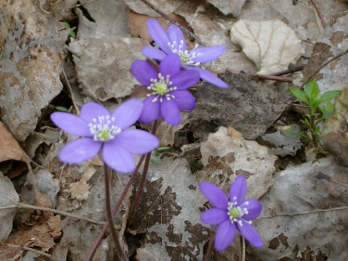
e-mail: Astrid.e.kure@hiof.no
phone: 69608302 (office) 95786628 (mobile)



